Parkinson’s disease Prediction

* **Install the following Libraries**

pip install ydata-profiling

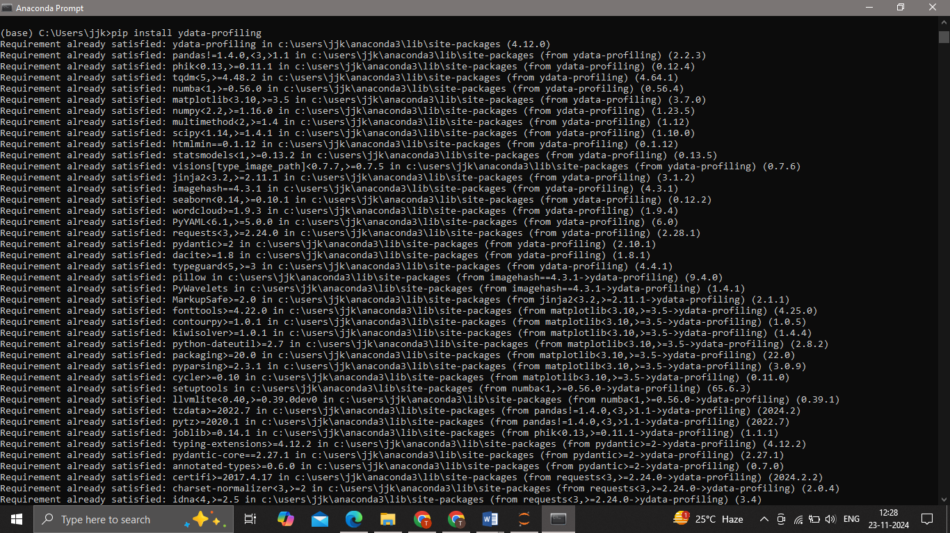

conda install -c conda-forge pandas-profiling

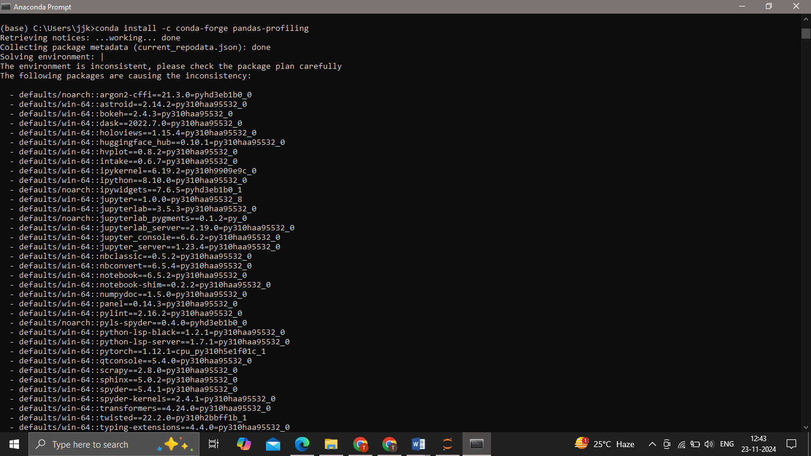

pip install visions

